**ME 312 – Manufacturing Technology II**

**Project Report**

Team Members:

Kathir Ilakkiyan S M – 200103125

Aprameya Rangarajan – 200103124

R Kailash – 200103088

Project Title: **Effect of Cutting Fluid on Surface Roughness during Turning Machining Operation.**

Aim:

1. To perform turning operations with and without cutting fluid by varying the feed and cutting speed of the lathe machine.
2. To compare the surface roughness of the work piece surfaces produced by turning operation while using and not using cutting fluid.

Theory:

Turning is a machining operation performed by a lathe machine. Lathe operates on the principle of a rotating work piece and a fixed cutting tool. The cutting tool is feed into the work piece which rotates about its own axis causing the work piece to form the desired shape.

Cutting fluids are liquids that are commonly applied while machining (or cutting) operation is taking place. They act as lubricant as well as coolant. They reduce the friction between tool and work piece as well as tool and chip. This results in better tool life and better surface finish of the work piece.

Surface roughness is the measure of the finely spaced micro-irregularities on the surface texture of machined product. It determines the surface finish of the product. Less the surface roughness, better is the product quality and surface finish. Surface roughness can be measured using surface roughness tester.

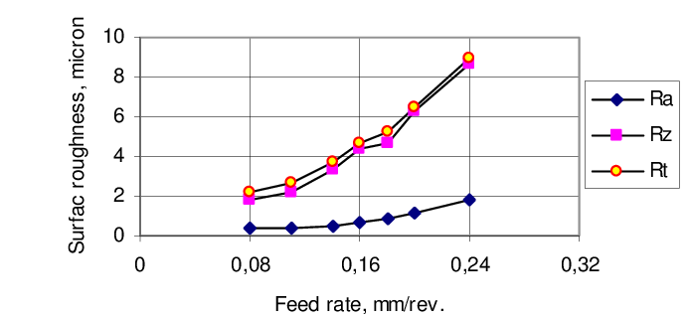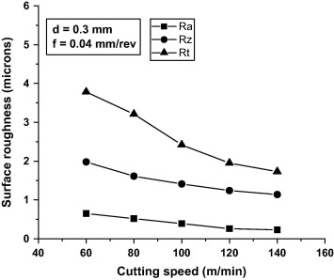

The surface roughness increases with the increase in feed of the machine and it decreases with increase in cutting speed or the rpm of the machine.

Apparatus Required:

1. Lathe Machine
2. Cutting tool
3. Cylindrical work piece
4. Cutting fluid
5. Surface roughness tester



Fig.1 Lathe Machine

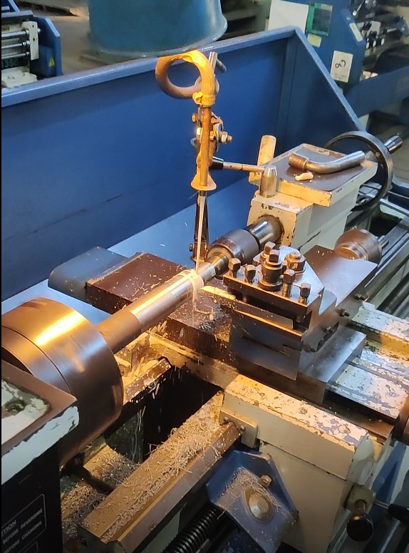

Fig.2 Cutting Fluid

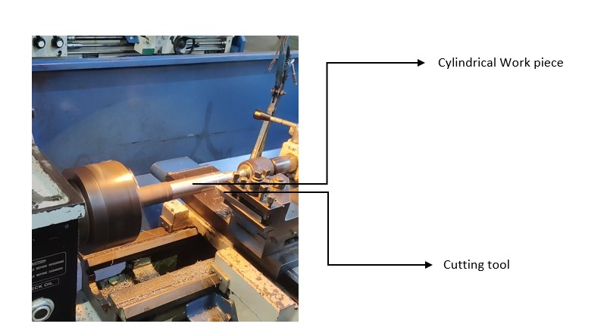

Fig.3 Work piece and Cutting tool

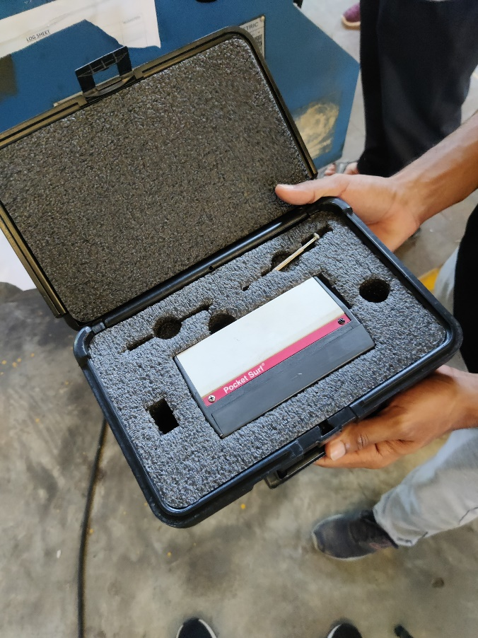

Fig.4 Surface roughness tester

Procedure:

1. Mount the work piece to the spindle and the cutting tool to the tool holder.
2. Set required feed and cutting speed for the machine.
3. Start the machining process and note the time taken for particular length of cut.
4. Change the feed and repeat the process twice.
5. Measure the surface roughness of surfaces produced for different feeds.
6. Now repeat the above steps while engaging cutting fluid.
7. Change the cutting speed and repeat the machining process.
8. Measure the surface roughness again for different feeds with and without cutting fluid.
9. Record the observed values in a table.

Observations:

Initial diameter of work piece, D= 36.8 mm

Length of each cut, l = 20 mm

Depth of cut, d = 0.2 mm

Nose Radius of cutting tool, R = 0.1 mm

|  |  |  |  |  |  |  |  |
| --- | --- | --- | --- | --- | --- | --- | --- |
| S.no | Cutting fluid | N (rpm) | Feed (mm/rev) | Machining Time (s) | Surface roughness, Ra (μm) | | Mean Surface roughness, Ra (μm) |
| Reading 1 | Reading 2 |
| 1 | Off | 384 | 0.040 | 79.21 | 1.86 | 1.76 | 1.81 |
| 2 | 0.065 | 48.01 | 2.71 | 2.98 | 2.845 |
| 3 | 0.105 | 29.99 | 3.50 | 3.36 | 3.43 |
| 4 | On | 384 | 0.040 | 78.75 | 1.70 | 1.66 | 1.68 |
| 5 | 0.065 | 47.60 | 2.61 | 2.41 | 2.51 |
| 6 | 0.105 | 30.39 | 3.03 | 3.28 | 3.155 |
| 7 | Off | 598 | 0.040 | 50.90 | 1.60 | 1.51 | 1.555 |
| 8 | 0.065 | 31.29 | 1.99 | 1.84 | 1.915 |
| 9 | 0.105 | 19.03 | 2.52 | 2.34 | 2.43 |
| 10 | On | 598 | 0.040 | 50.82 | 1.21 | 1.10 | 1.155 |
| 11 | 0.065 | 31.80 | 1.55 | 1.67 | 1.61 |
| 12 | 0.105 | 19.05 | 1.83 | 1.89 | 1.86 |

Table 1 Surface roughness for various feed and rpm

Calculations:

Theoretically average surface roughness Ra is given by the formula,

Ra = 0.0321 x f2/R

Where, f – feed, R – nose radius

* For feed = 0.040 mm/rev,

Ra = 0.514 μm

* For feed = 0.065 mm/rev,

Ra = 1.35 μm

* For feed = 0.105 mm/rev,

Ra = 3.54 μm

Results:

Turning operation has been performed using different cutting speed and feed successfully. The surface roughness has been recorded for surfaces machined using different feed, cutting speed and with and without cutting fluid.

* With increase in feed, machining time decreases.
* With increase in cutting speed (πDN), machining time decreases.
* With increase in feed, surface roughness increases.
* With increase in cutting speed, surface roughness decreases.
* While engaging cutting fluid, for same cutting speed and feed, surface roughness decreases.

Conclusions:

1. For better surface finish, it is preferable to machine with higher rpm and lower feed.
2. Using cutting fluid, not only acts as a coolant, but also produces better surface finish for the product.
3. Machining with higher cutting speed and lower feed while engaging cutting fluid gives us the best surface finish for the product.

Precautions:

1. Set the feed and rpm properly before starting the machining process.
2. Make sure the work piece and cutting tool are tightly clamped to the spindle and tool holder respectively.
3. Be aware to stop the machine exactly after the required length for proper machining time.
4. Apply cutting fluid exactly at the location of cutting.
5. Do not shake the surface roughness tester while taking the reading.